Name: Jiahui Wu

ID: 2670210

Lab #0

Description: Use the Game sales Data to Predict which Computer Game Genres/Platforms Will Be the Best to Focus/Invest for Next Year 2017 Globally and For Each Region.

1. To predict which genre to focus globally and for each region.

1-1. First I selected the column of ‘year’, then sort by year.

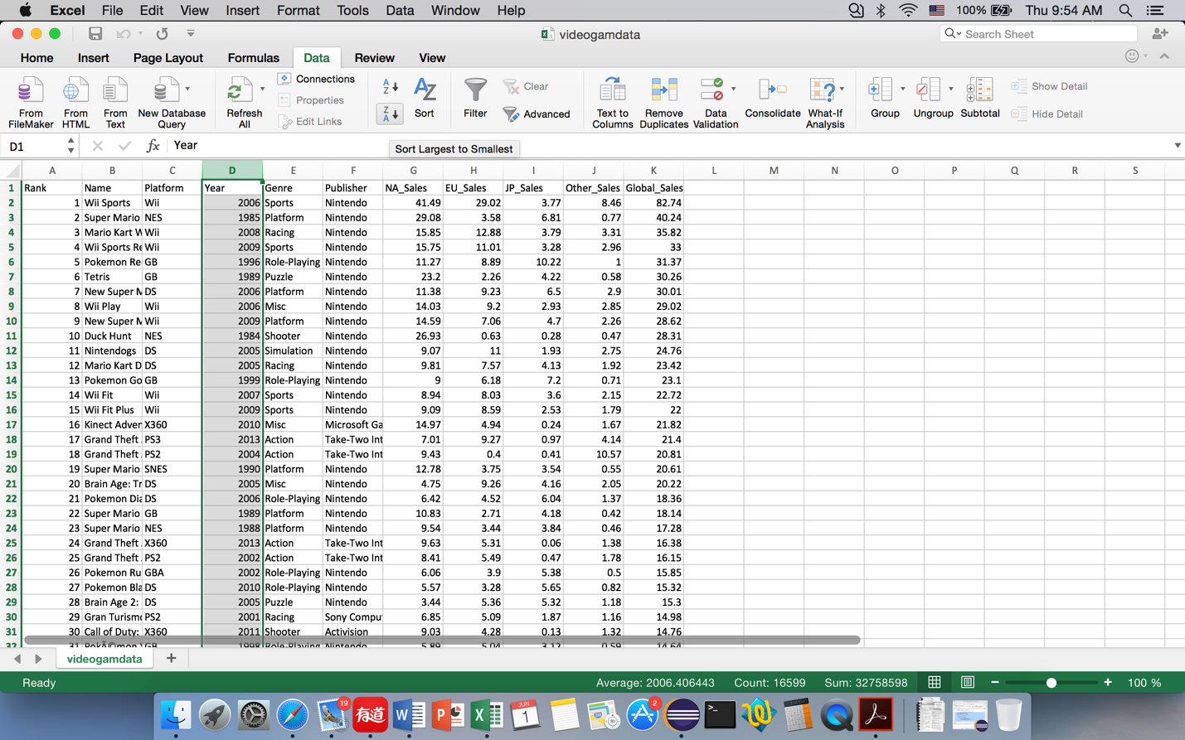

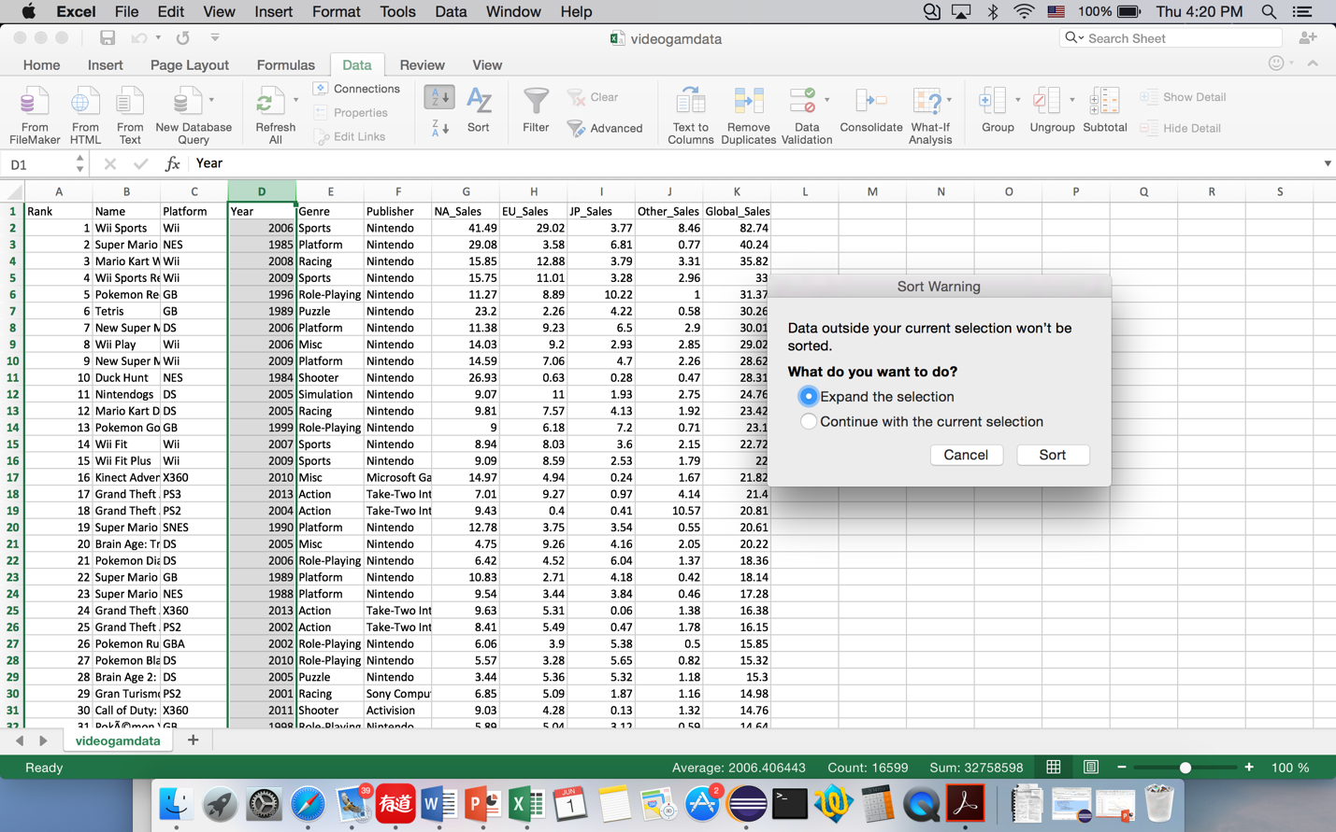

1-2. Then I inserted new sheets to copy the data of each year to separate sheet. I chose 10 years from 2016, which is from 2007 to 2016 to show the sales changes in genres.

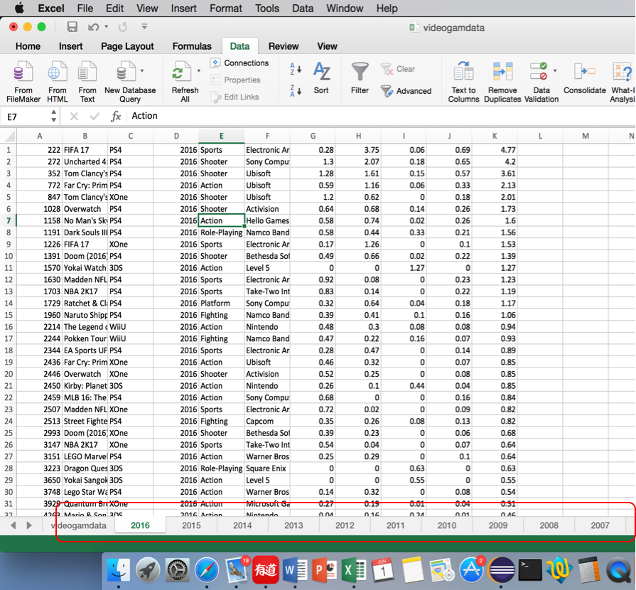

1-3. In each year, to get the sum of sales in different genre, I selected column ‘genre’ and sorted A-Z. The following takes year 2016 as example, manipulations of data from other years are the same.

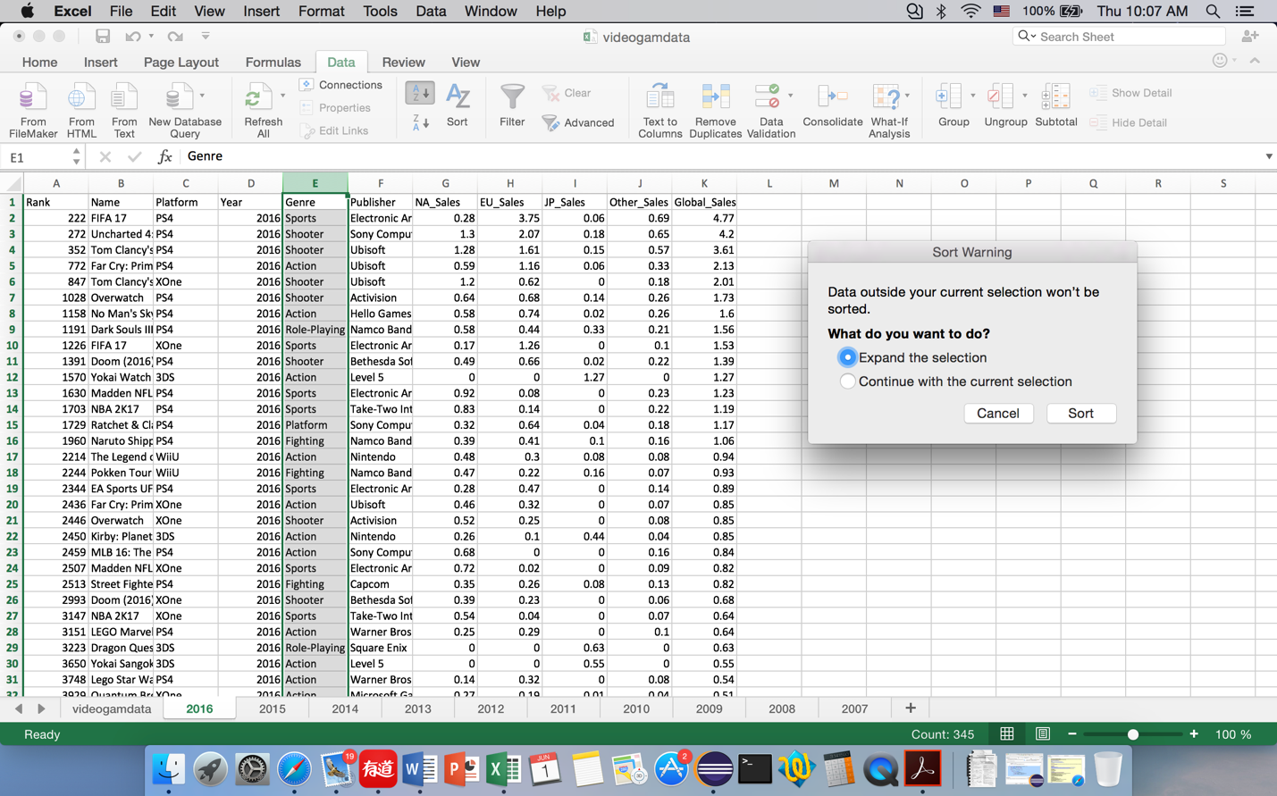

And this is what I got.

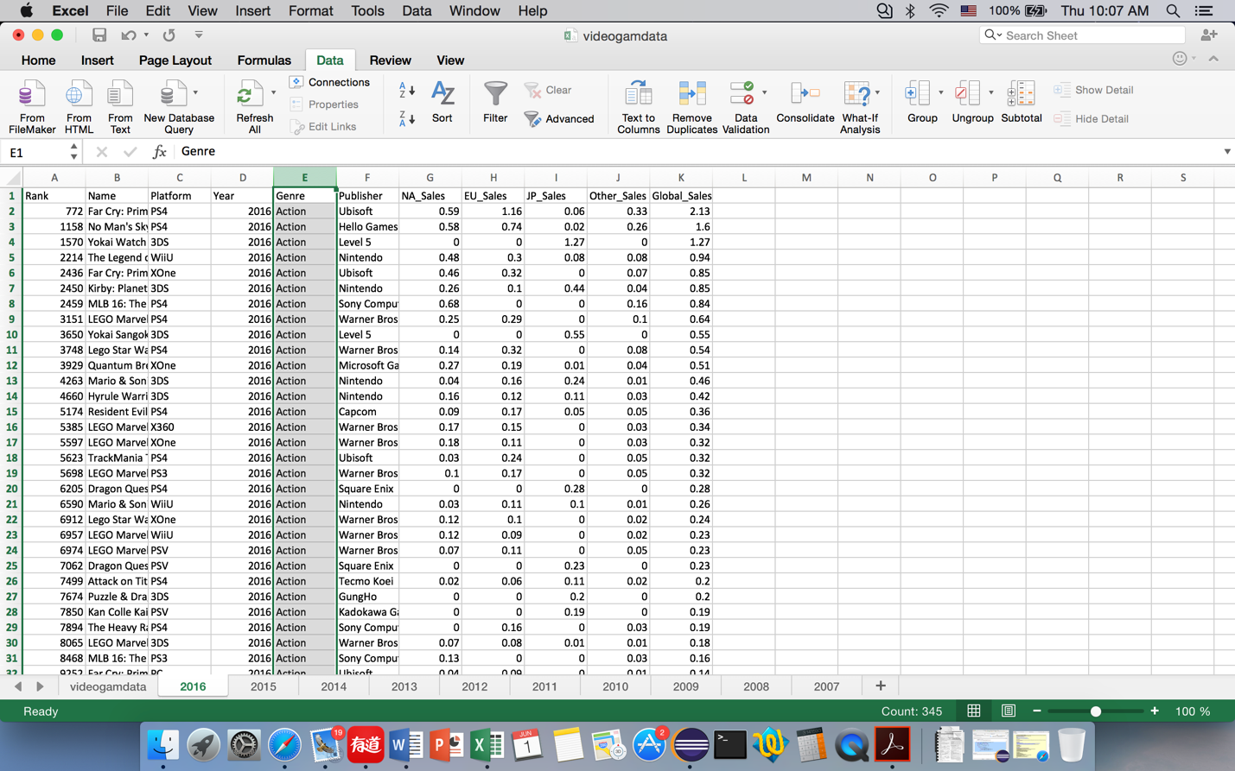

1-4. After sorting, I selected all the data of each year, click ‘Subtotal’ and choose At each change in: Genre; Use function: Sum; Add subtotal to: NA_Sales, EU_Sales, JP_Sales, Other_Sales, Global_Sales. Hit OK and get the subtotals.

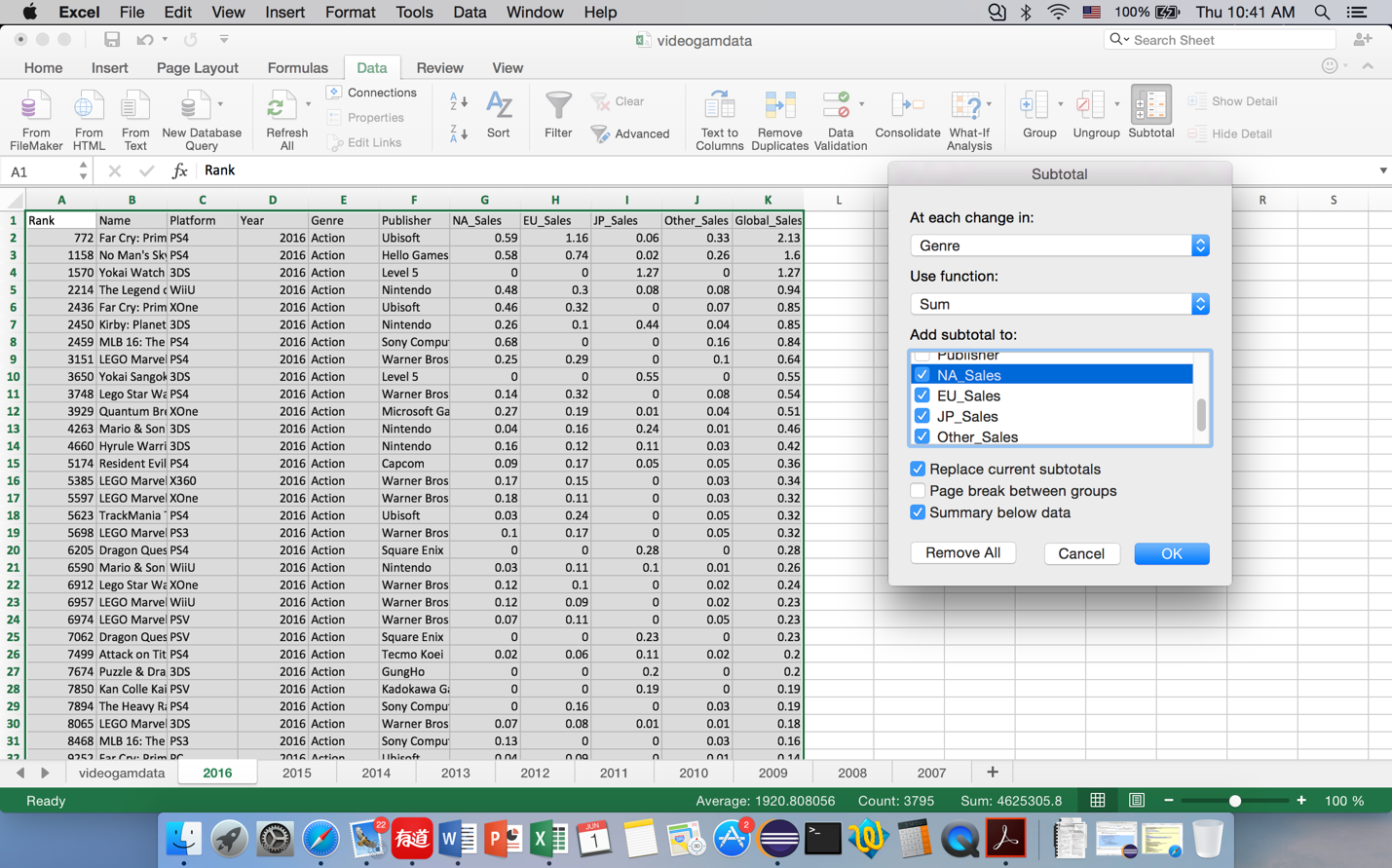

Here is part of the data shows two of the subtotals:

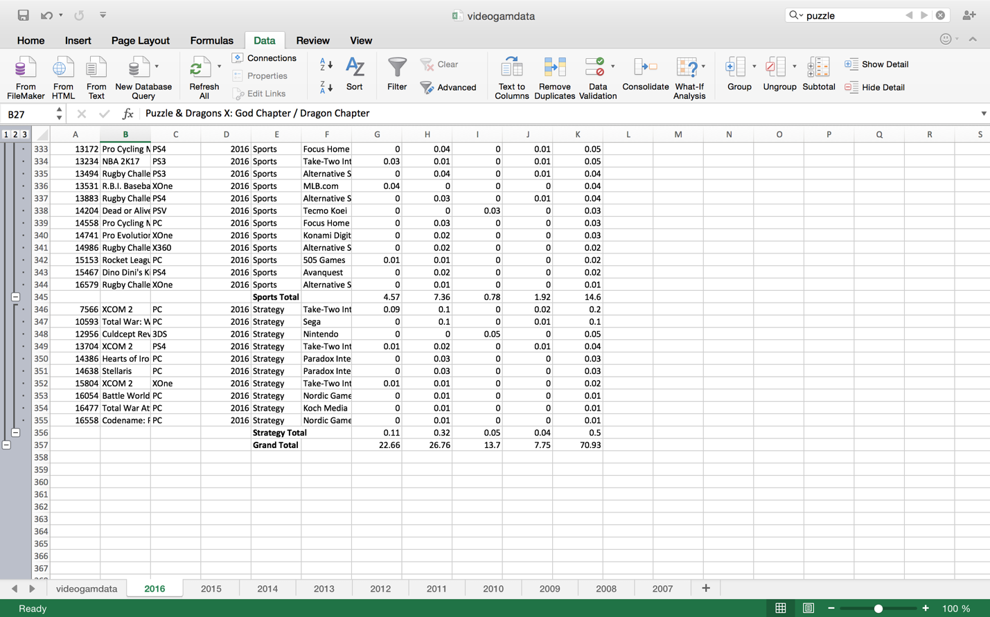

1-5. I copied the subtotals of each genre of each year and got the following data. I plotted scatted graphs using the data, and got one graph for each region, the graph can be used for prediction. The order is: Global_Sales, NA_Sales, EU_Sales, JP_Sales, Other_Sales.

Global_Sales:

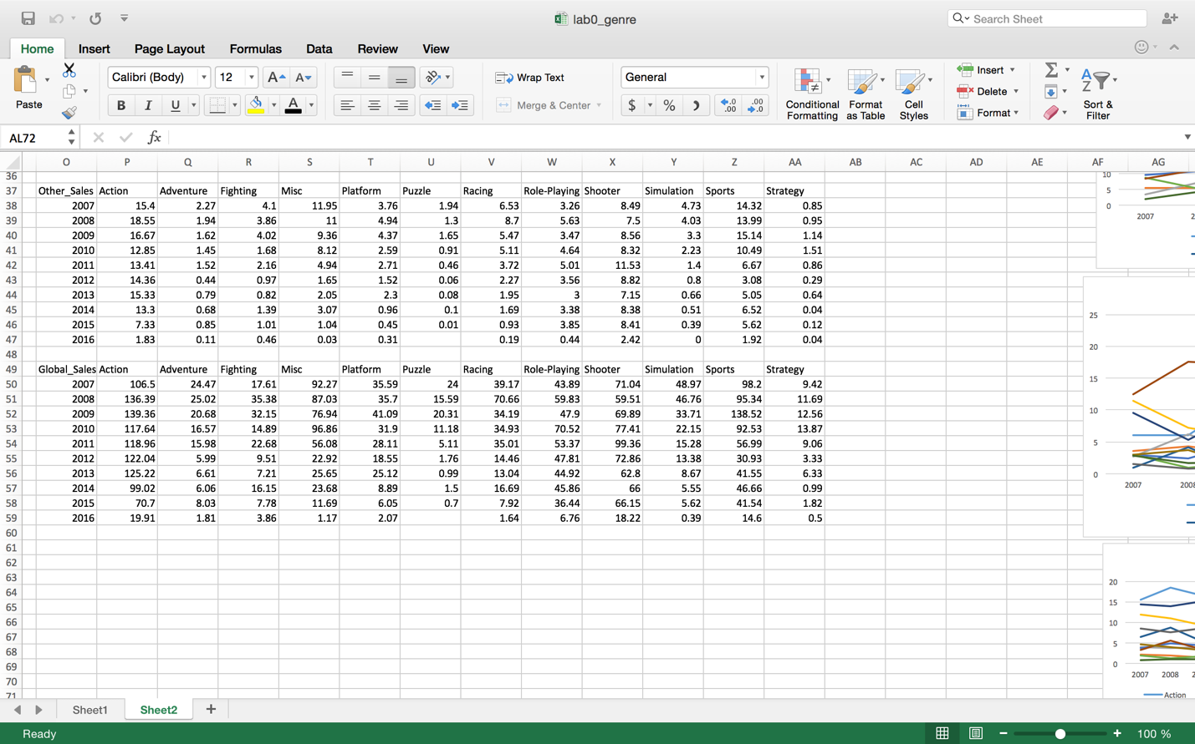

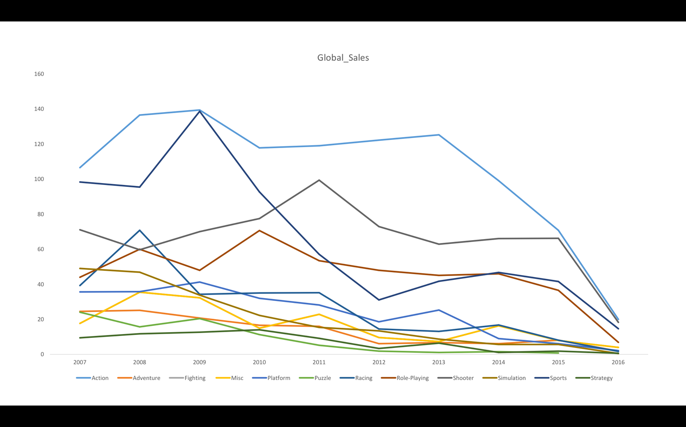

NA_Sales

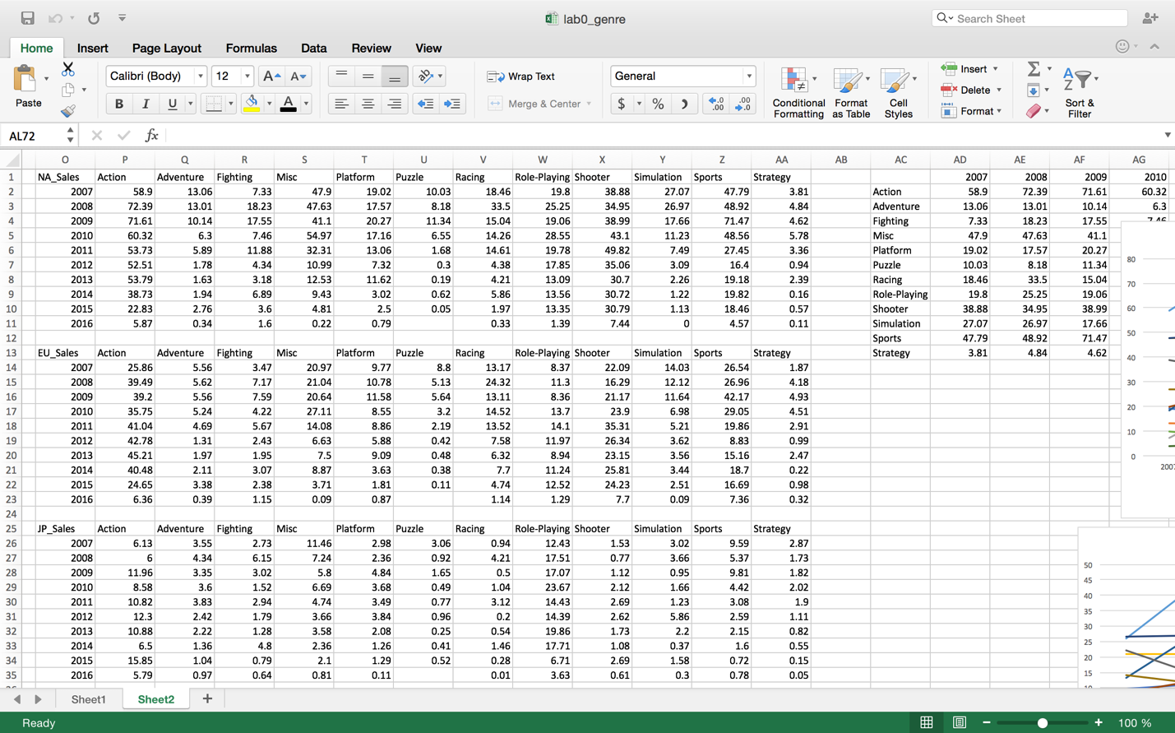

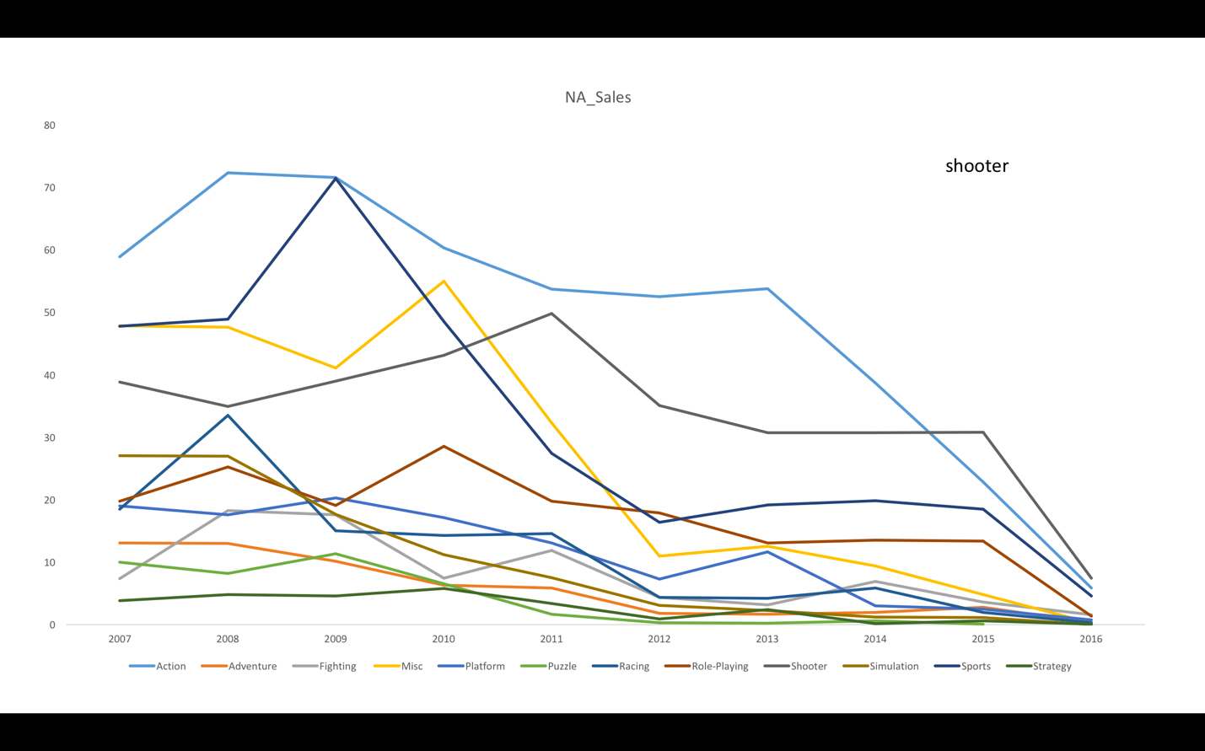

EU_Sales



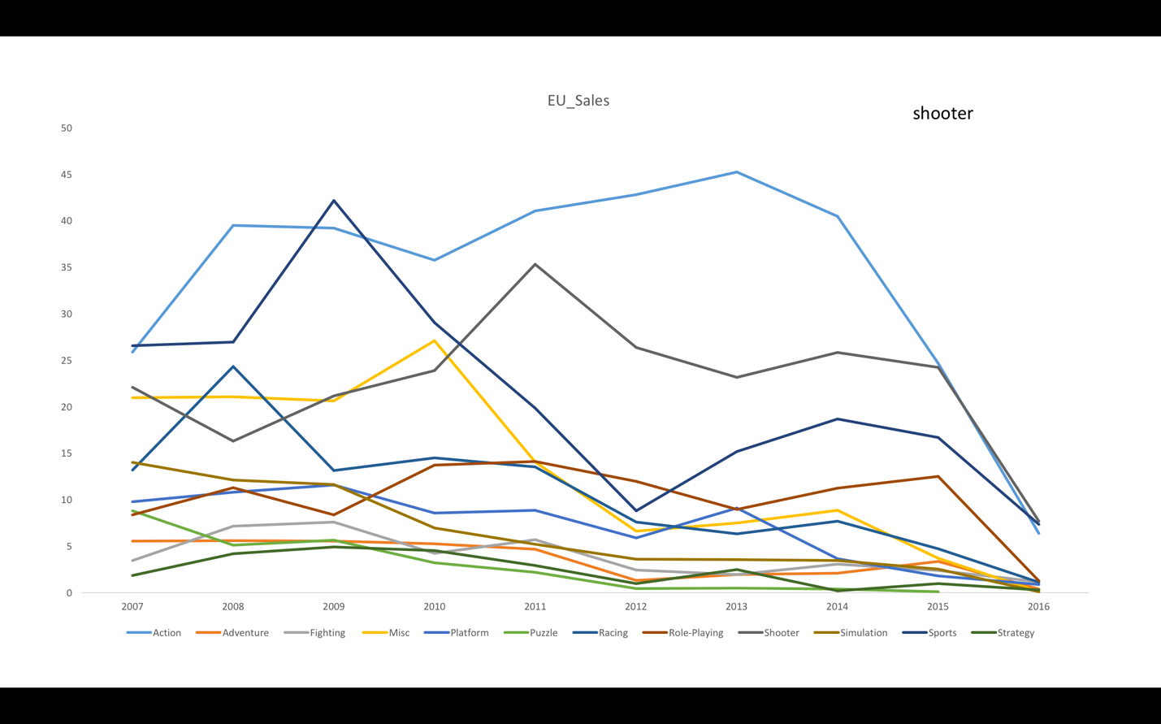

JP_Sales



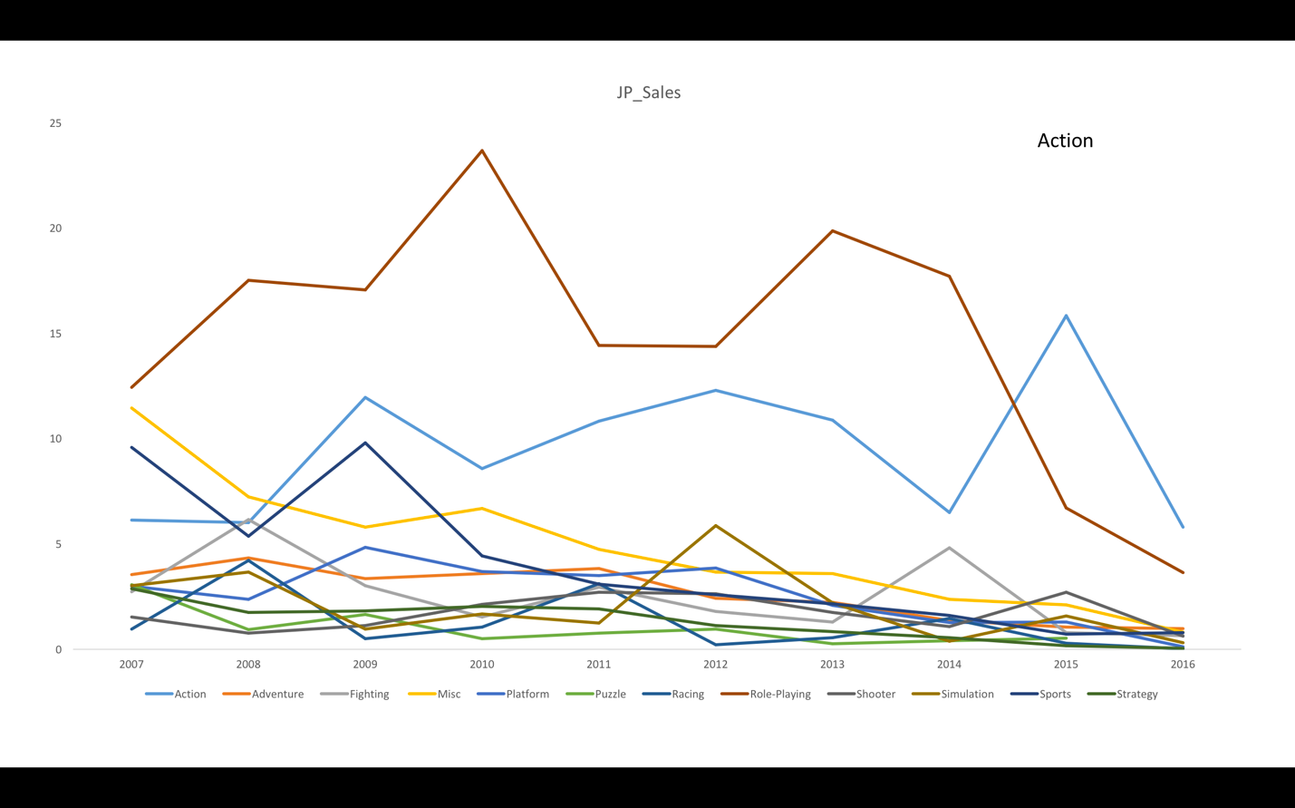

Other_Sales



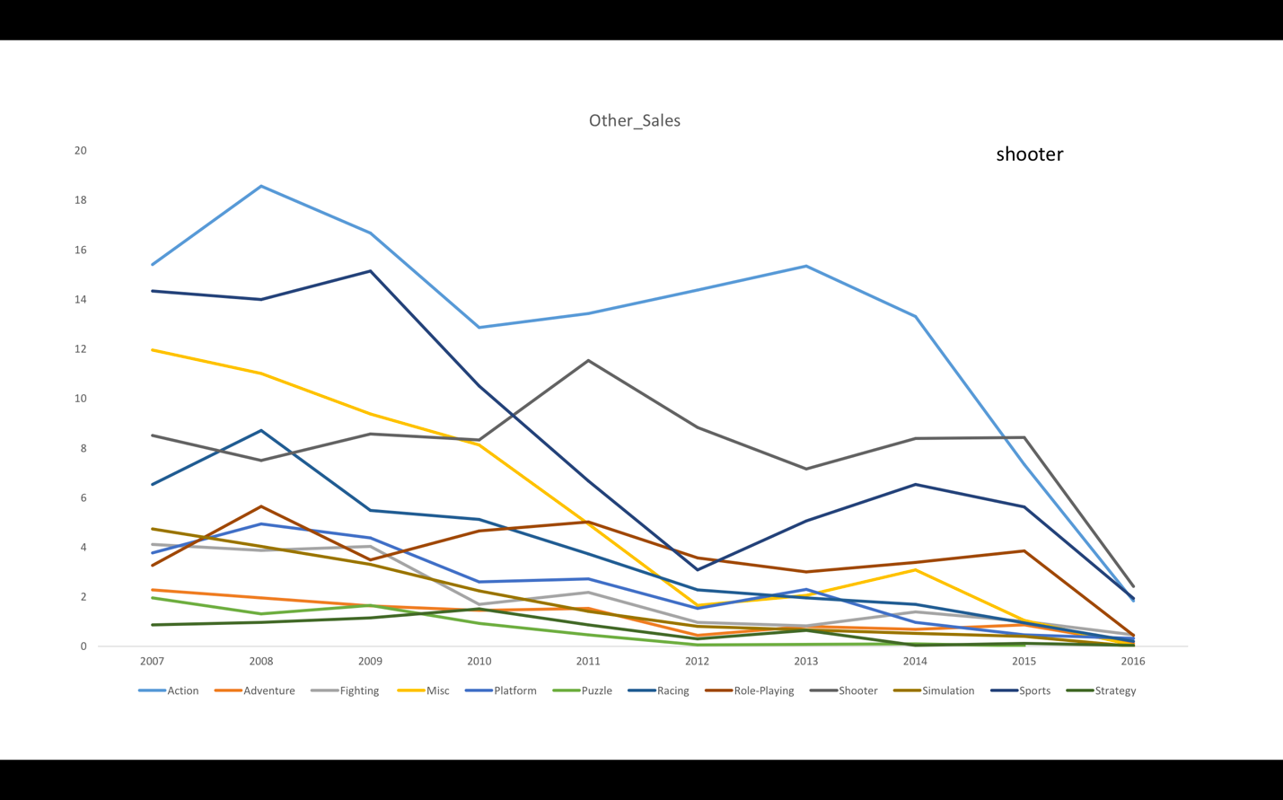

According to the curve, the best genre to focus in year 2017 is (the first row):

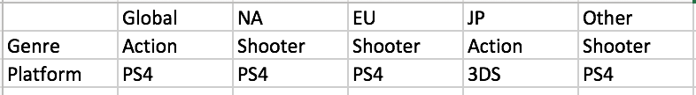

Because the sale of the chosen genre is strongest in recent year in comparison with other genres.

2. To predict which platform to focus in year 2017. Since the upgrading speed of platforms is very fast, the data from years ago is not very useful in prediction, for example, platform DS is widely used until year 2014, so we do not need the data of DS to predict the platform in 2017. I chose 5 years from 2016 for prediction, which is from 2012- 2016.

2-1. Using the same data sheets of year 2012-2016, first I sorted the platform (shown in year 2016 as example).

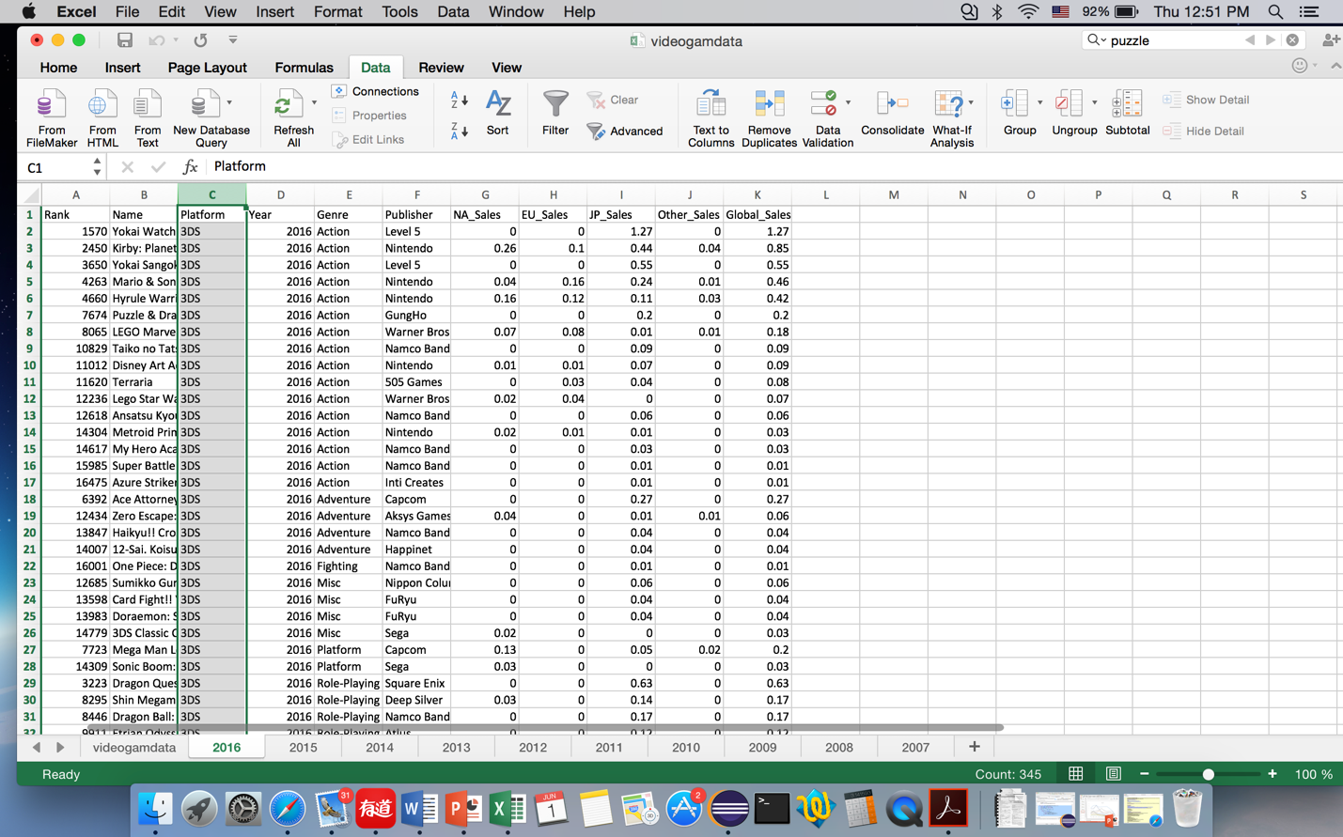

2-2. Then I calculated the sale subtotals of each platform. At each change in : Platform; Use Function: Sum; Add subtotal to : NA_sales, EU_sales, JP_sales, Other_Sales and Global Sales.

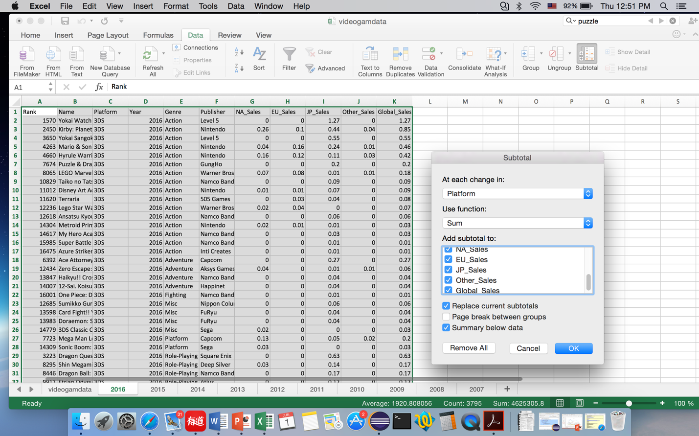

Part of the data after subtotal

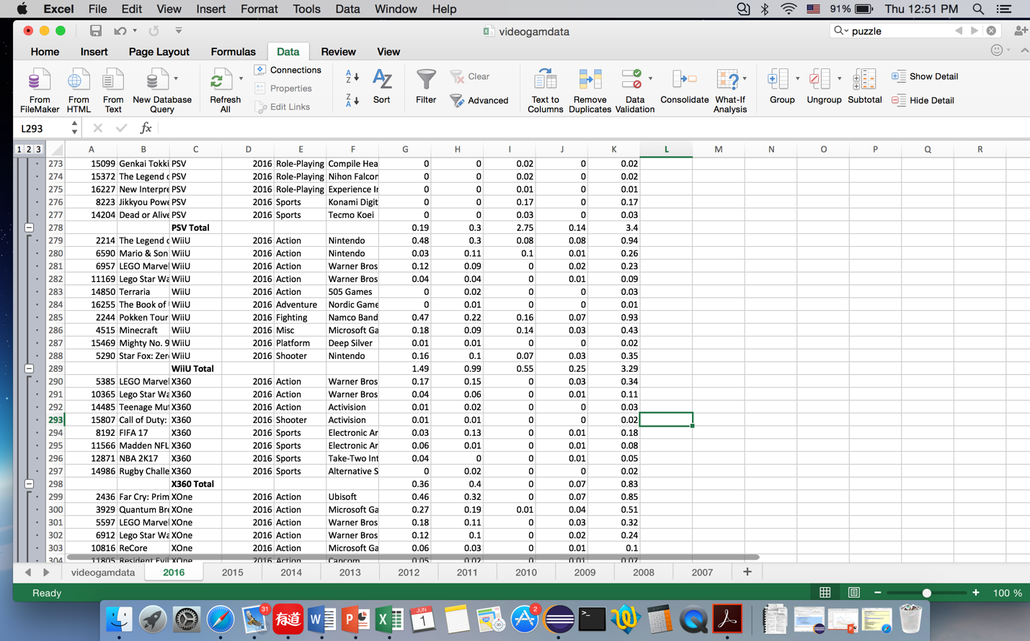

2-3. Copy subtotal data of each year, remove DS cause this platform is obsolete. Plot graphs.

Global_Sales

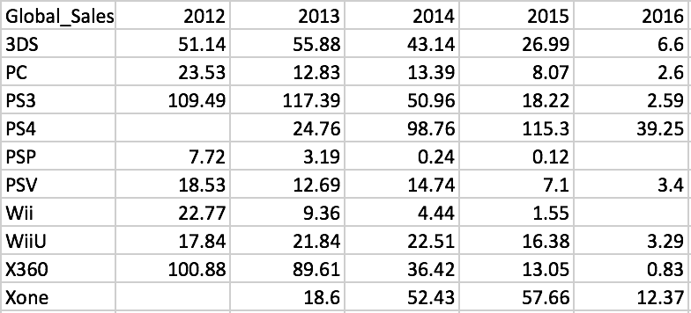

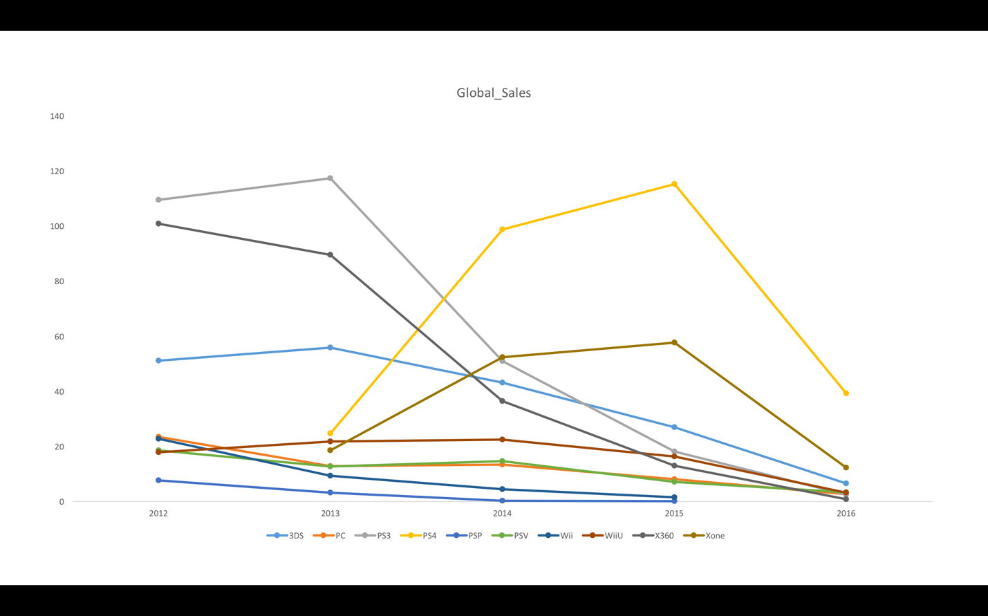

NA_Sales

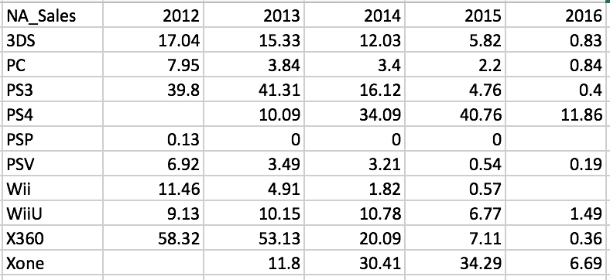

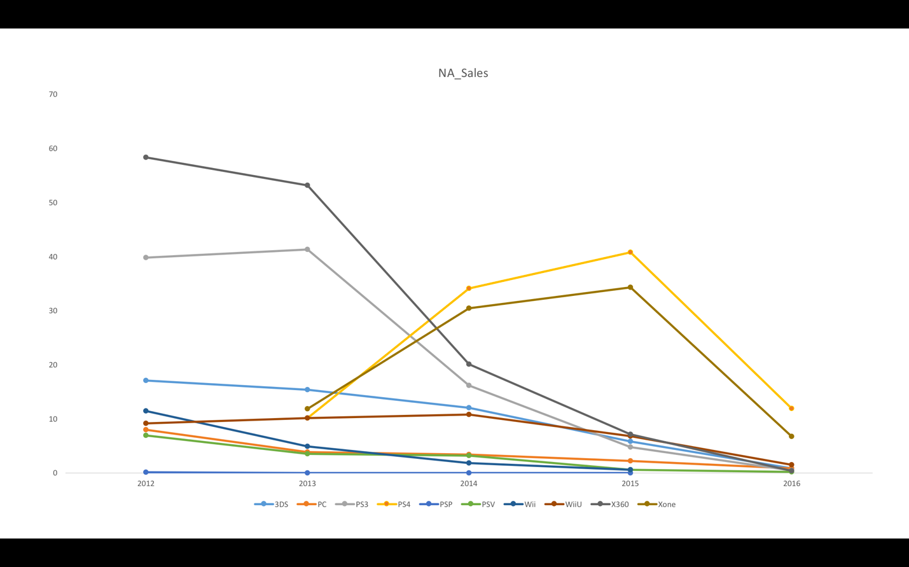

EU_Sales

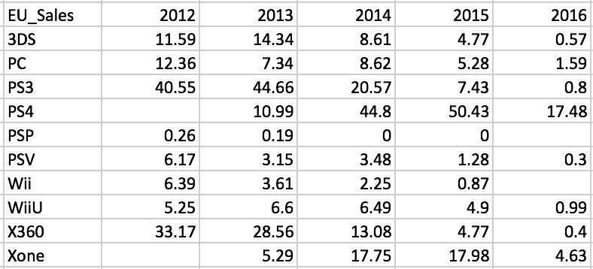

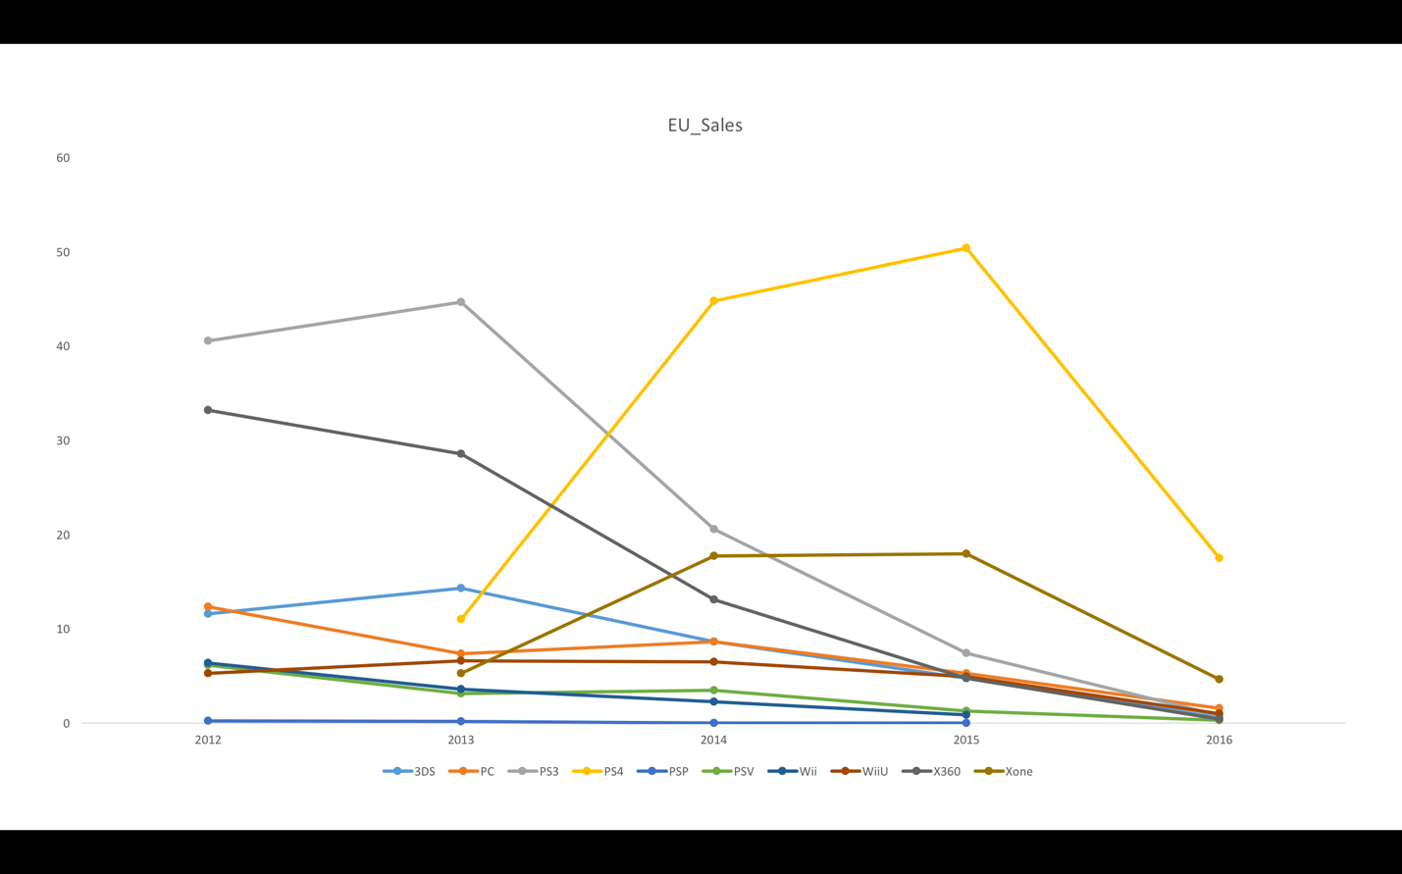

JP_Sales

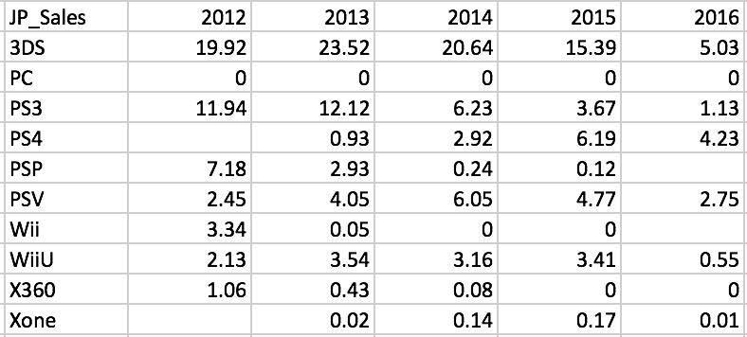

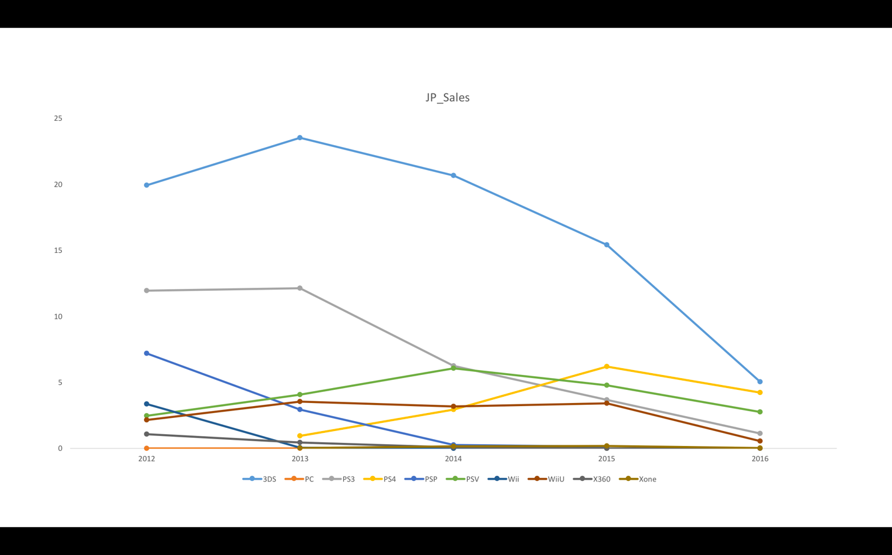

Other_Sales

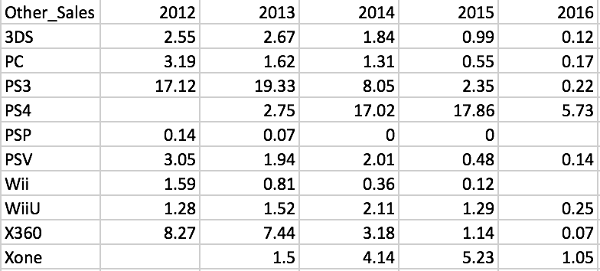

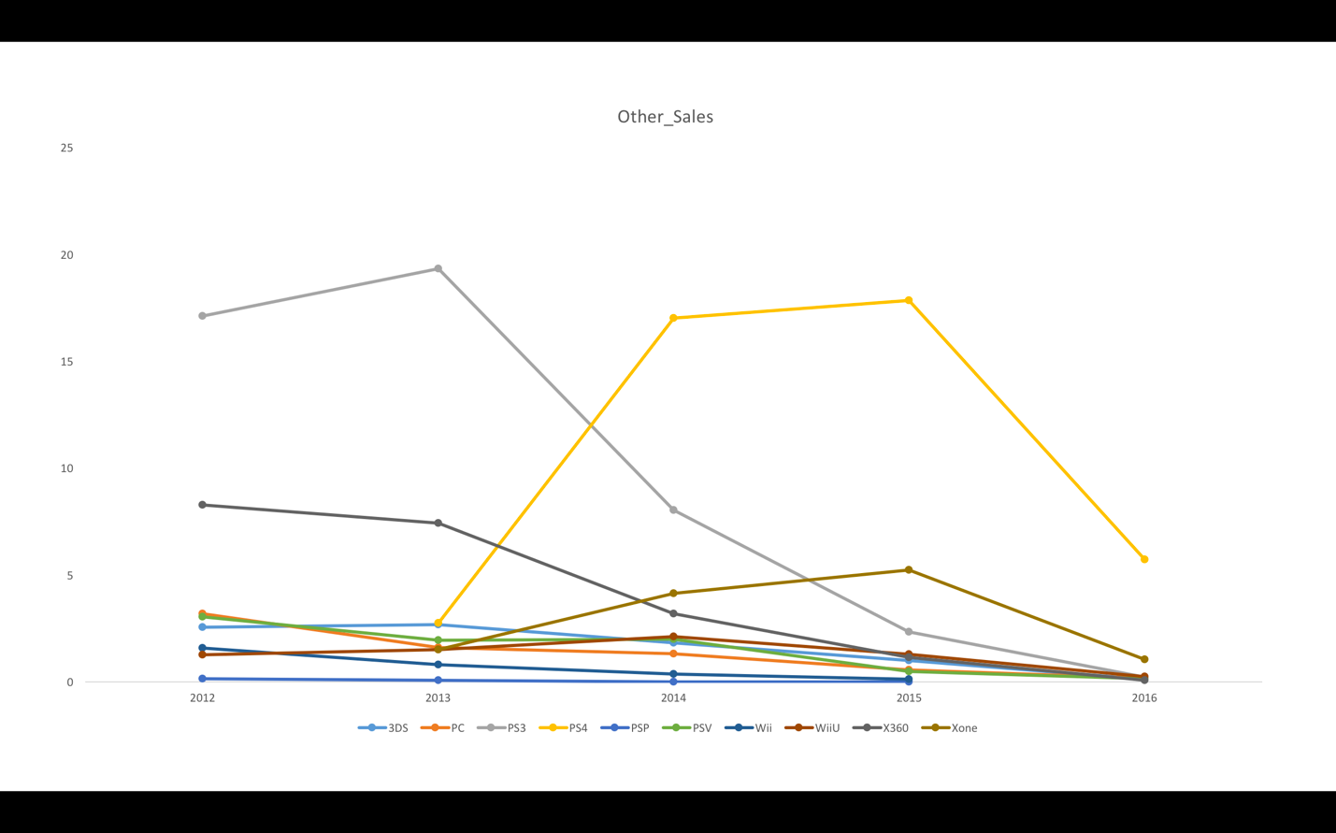

According to the graphs, the platform to focus in year 2017 are the following (see second row):



Because the sale of the chosen platform is strongest in recent year in comparison with other platforms.

All the sales almost hit bottom in year 2016, maybe because of market saturation. We could predict the company with new genre or new platform. It is risky because everything is unknown. However, it is a creative view to predict.